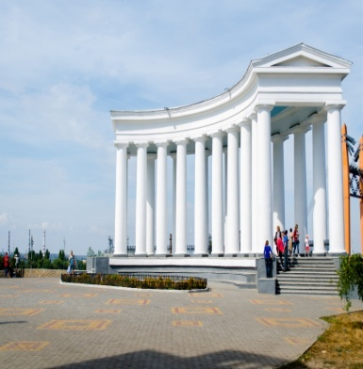
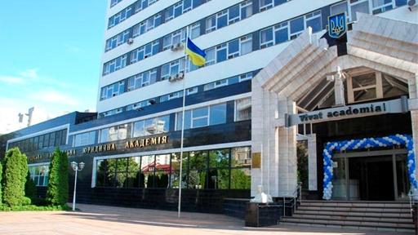
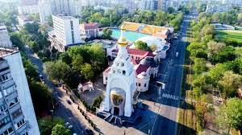
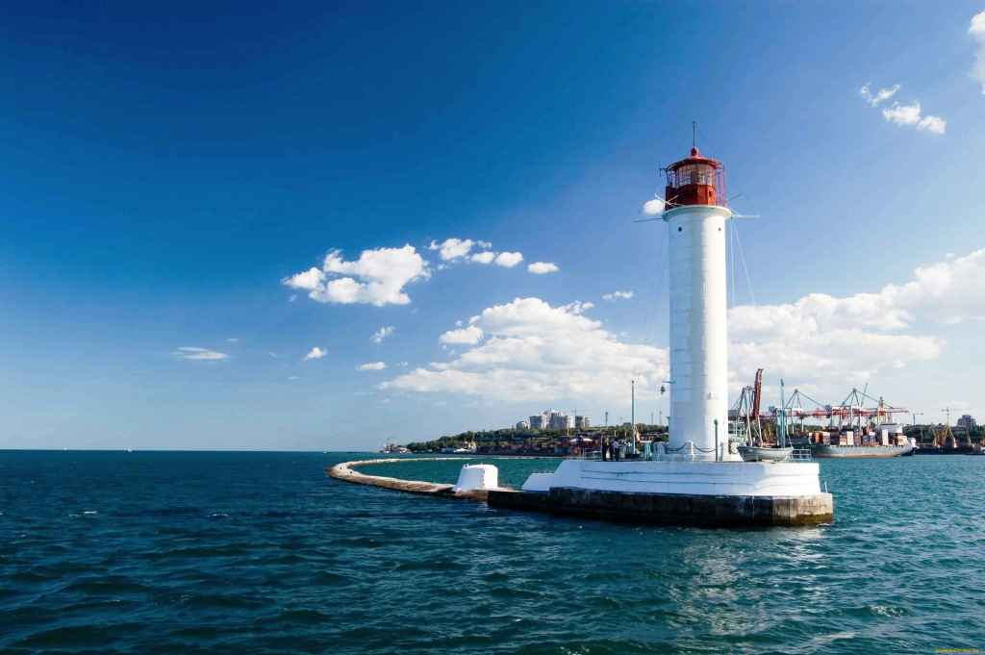
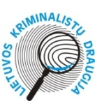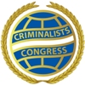

14 INTERNATIONAL CONGRESS
"CRIMINALISTICS AND FORENSIC
EXPERTOLOGY: SCIENCE, STUDIES, PRACTICE»
13-15 September, 2018
Odessa, Ukraine

Dear colleagues!
Criminalists' Association of Lithuania, International Criminalists Congress, Mykolas Romeris University and National University "Odessa Law Academy" will hold the 14th International Congress "Criminalistics and Forensic Expertology: science, study, practice" on 13-15 of September, 2018.
1. Time and venue:
The Congress will take place at the premises of the National University "Odessa Law Academy" (Academic Council Hall, 23 Fontanskaya Doroga Street, Odessa, Ukraine) on 13-15 of September, 2018.

2. Agenda:
- The process of globalization and internationalization of criminality; the need for international harmonization of scientific research in the field of criminalistics and forensic expertology;
- The role and place of non-government international organizations in the development of criminalisitcs and forensic examination;
- Special knowledge as an instrument for implementation of scientific achievements into the process of pre-trial investigation and judicial proceedings;
- Criminalistical metodics the traditional path of development of crime investigation or the way of implementation of contemporary management methods?;
- The problematic issues of the development of certain directions in forensic examination;
- The innovative methods within criminalistic and forensic didactics.
3. Working languages of the Congress: English, Ukrainian and Russian (simultaneous interpretation is provided). Plenary sessions and poster presentations will be held.

4. Significant dates:
Until March 15, 2018:
the application forms should be filled in via the following link: https://docs.google.com/forms/d/1TX4SxUp5uejS5HUBpbeHAhzT7n7GN6V5mzztjjDfCJk/prefill or the printed version of the application forms (the sample form is attached) should be sent to the e-mail defined below;
one page of the article summary (in the original language) should be sent to the email below (the title of the article and author information should be specified in English as well).
Until April 30, 2018:
the article (in the original language) and the summary (in the original language and in English) should be sent to kongresodessa2018@gmail.com
Articles can be prepared in all EU official languages, Ukrainian or Russian. Each article should approximately consist of 14 printed pages.

The structure of the article: title; author information (name, surname, academic degree and rank, name of institution and position, postal address, phone number, e-mail); abstract (200 - 400 characters). The abstract of the article should cover the content and the main issues analyzed (in the original language). 5-8 key words should be specified separately; introduction (rationale of the article, its originality, research objectives and subject matter, applied scientific methods, etc.) should be disclosed. Each article, regardless of the language, should contain a summary (1500 to 2000 characters), as well as keywords in English at the end. The summary should reflect the existing issues, conclusions and recommendations, analyzed in the article. The title of the summary should be in English with capital letters. Author information (name, surname, academic degree and rank, name of institution and position) should be indicated in English as well. References, used in the article, should be indicated at the bottom of a page. Bibliographical references are not required.
Articles will be reviewed by the Scientific Committee of the 14th International Congress, retaining the right to select materials for the publication.
5. Conditions of participation:
The Congress registration fee is 130 euros (for the members of the International Criminalists Congress the fee is 70 euros). The registration fee includes the organizational expenses. Payment can be made via bank transfer. The transfer is made to the account of the Criminalists' Association of Lithuania № LT 10 7044 0600 0159 7508, SWIFT CBVI LT 2X (BANKA). Participant's name and surname must be specified. The fee can be paid in cash before the Congress (all information, upon an individual request, will be provided by the organizing committee).

6. Preliminary programme of the Congress:
September 13, 2018 (Thursday) | September 14, 2018 (Friday) | September 15, 2018 (Saturday)
12.00-14.00 Participants' registration  12.30-13.30  14.00-14.30 Official opening ceremony  14.30-16.00 Plenary session  16.00-16.15  16.15-18.00 Plenary session  19.00-21.00 Gala reception | 9.00-10.45 Plenary session  10.45-11.00  11.00-13.00 Plenary session/poster presenations  13.00-14.00  14.00-16.00 Plenary session  16.00-16.15  16.15-18.00 Plenary session  19.00-22.00 Boat tour and gala dinner | 9.00 – 10.45 Plenary session  10.45-11.00  11.00-13.00 Plenary session and closing ceremony  13.00-14.00  Odessa sightseeing tour
See you in Odessa!

Contacts:
Coordinator: Olesya Vashchuk (phone.: + 380675597646; + 380487996651)
Email: kongresodessa2018@gmail.com
Web page: http://14congress.onua.edu.ua

14 INTERNATIONAL CONGRESS

"CRIMINALISTICS AND FORENSIC

EXPERTOLOGY: SCIENCE, STUDIES, PRACTICE»

Odessa, Ukraine 13-15 of September, 2018
Organizing Committee: 23 Fontanskaya Doroga Street, Odessa, 65009 Ukraine Tel. + 380675597646; + 380487996651; E-mail: kongresodessa2018@gmail.com

REGISTRATION FORM

Name
Surname
Academic degree Academic rank
Name of institution
Position
Postal address
Phone number
Fax
Email
I would like to participate in the Congress. Subject matter of the article

Co-authors of the article

Accompanying person
Name
Surname
Planned date of arrival , 2018
Planned date of departure , 2018
Note: Hotel accommodation will be offered after receiving the filled entry form.

